

**Lab Manual**

**Finite Element Analysis**

**(ME – 411)**

**NATIONAL UNIVERSITY OF SCIENCES & TECHNOLOGY**

**PAKISTAN NAVY ENGINEERING COLLEGE**

**DEPARTMENT OF MECHANICAL ENGINEERING**

**FALL-2024**

**SUBMITTED BY : M. AHSAN JAMIL AWAN**

**REG. NO. : 383113**

**SUBMITTED TO : SIR AFFAN AHMED**

**Lab 01**

**Objective** :

* To simulate 25x75 rectangle static structurally
* add material in engineering data, define properties e.g. Young’s modulus, Poisson’s ratio

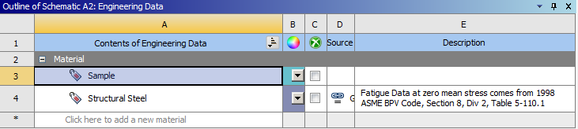

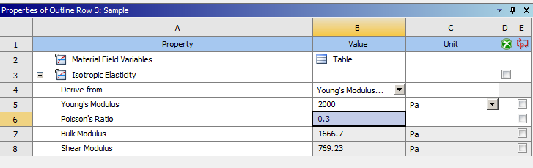

* Draw a rectangle of 25x75 and excrude it up to 1m

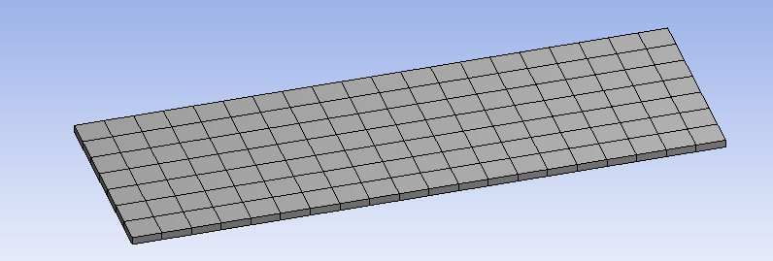

* Insert fixed support and select the bottom side to fixed it also insert force of 3000N on upper side.

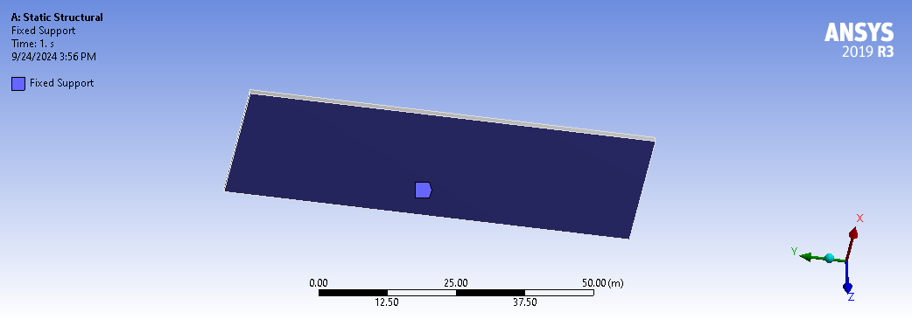

* Insert equivalent stress(von Mises)

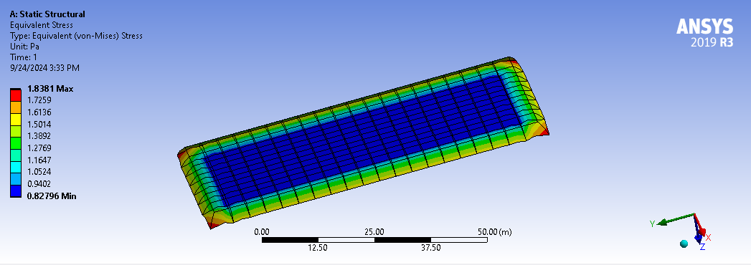

**Lab 02**

**Objective :**

* To simulate and compare the results of I beam of two different materials i.e. steel and concrete
* Add steel and concrete materials in engineering data

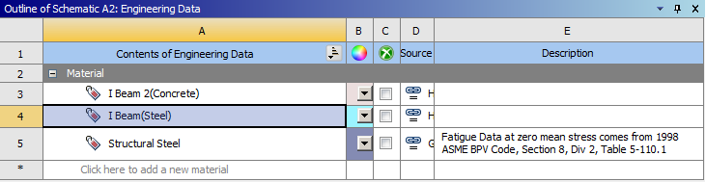

* Open design modeler, select cross section under concept tab and add I beam geometry

* excrude I beam geometry.

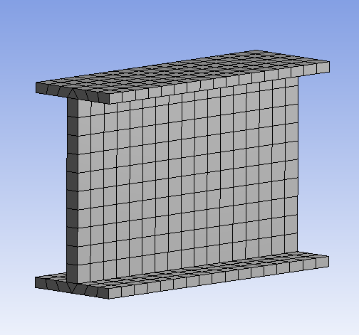

* Fixed front face and apply force in downward direction of 2000 N on top face of I beam

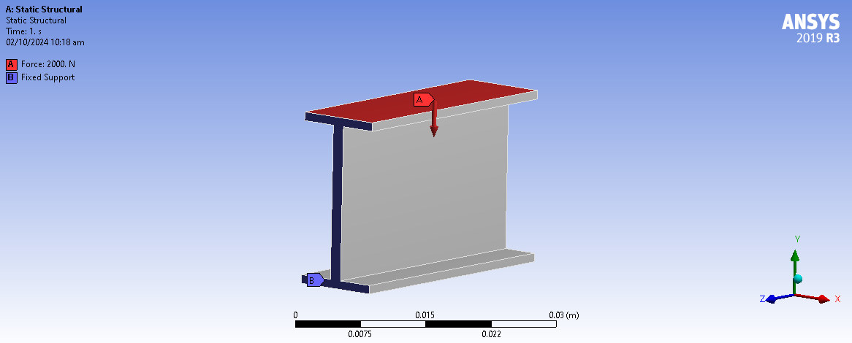

* equivalent stress and total deformation of steel and concrete

**Concrete**

(Total deformation) :

**Steel**

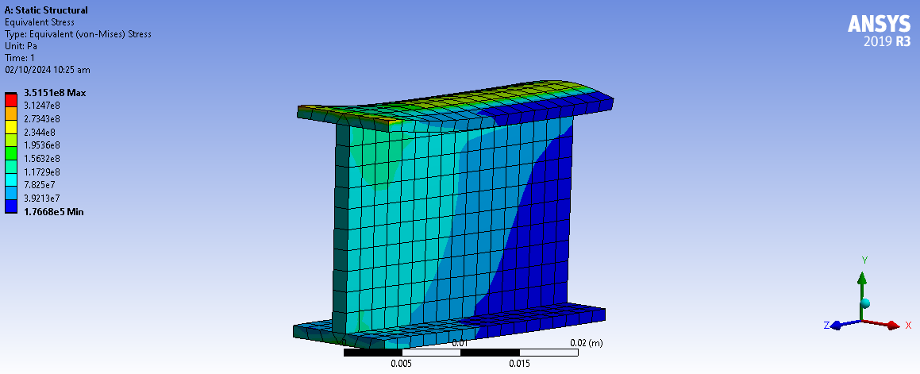

(Total deformation) :

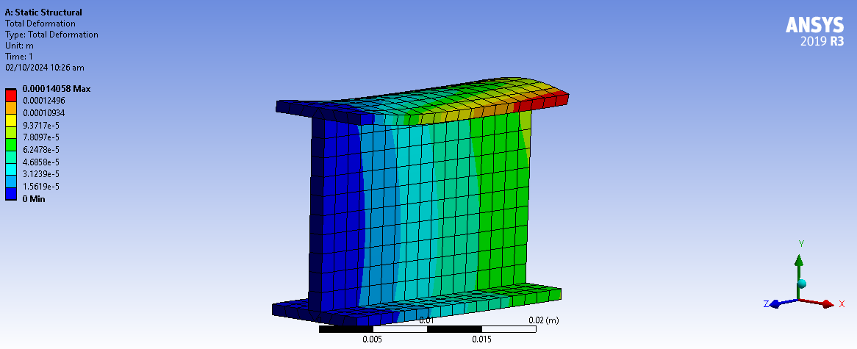

**Lab 03**

**Objective :**

* To compare Equivalent von-mises stress generated in T shape geometry with and without sharp edges
* Add structural steel in engineering data

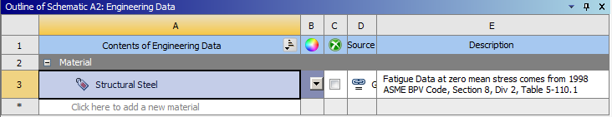

* Add T section under concept tab

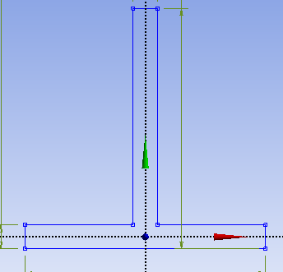

* Excrude geometry

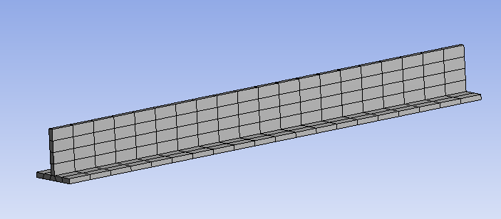

* fixed front and back face of T shape structure and apply pressure

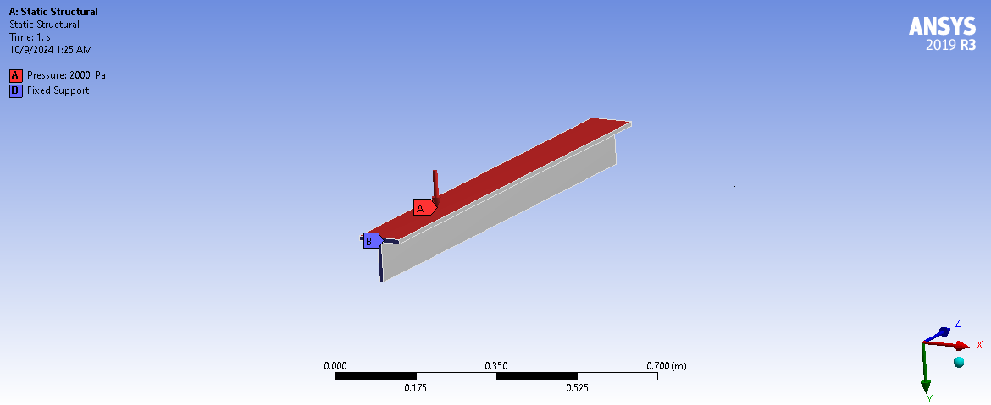

* Equivalent von-Mises stress

* Again , go to geometry ,select fixed radius under blend tab and select all the sharp edges in geometry to make them blend of radius 0.001m. Also generate mesh.

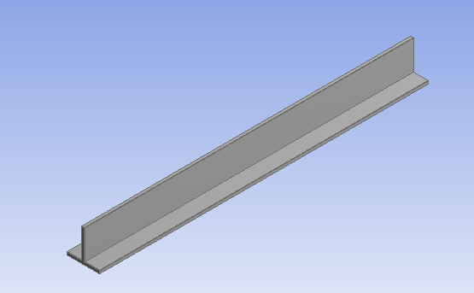

* Equivalent von-Mises stress and varying pressure magnitude.
* **Table :**

|  |  |  |
| --- | --- | --- |
| Pressure | Equivalent Von-Mises stress (sharp edges) Pa | Equivalent Von-Mises stress (Without sharp edges) Pa |
| 1000 | 3.9569e5 | 1.3203e6 |
| 2000 | 7.8128e5 | 2.3805e6 |
| 3000 | 1.3768e6 | 3.7608e6 |
| 4000 | 1.8694e6 | 4.8211e6 |
| 5000 | 1.923e6 | 5.9014e6 |

* **Graphs :**

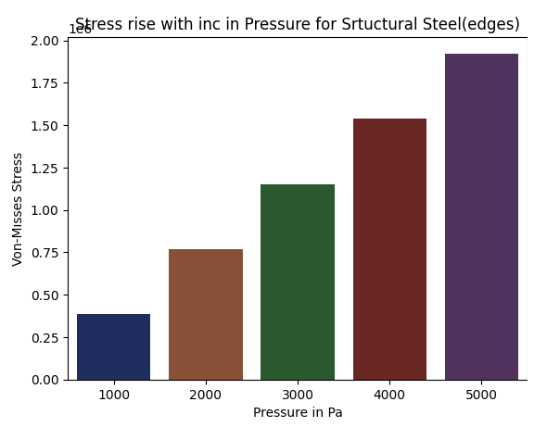

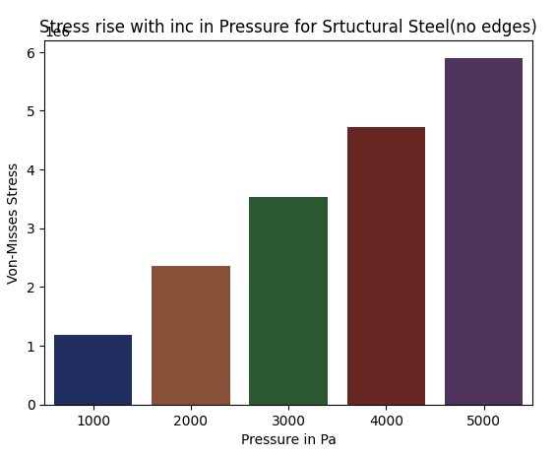

**Lab 04**

**Objective :**

* select structural steel 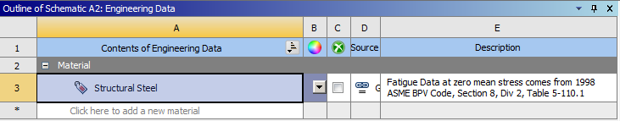
* go to create tab ,select primitives and then box 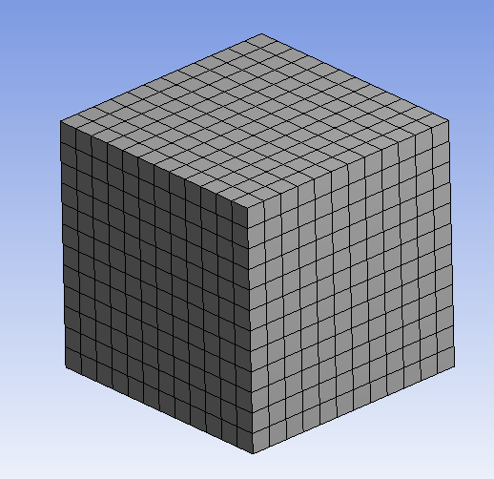
* fixed the bottom face of box and apply remote force 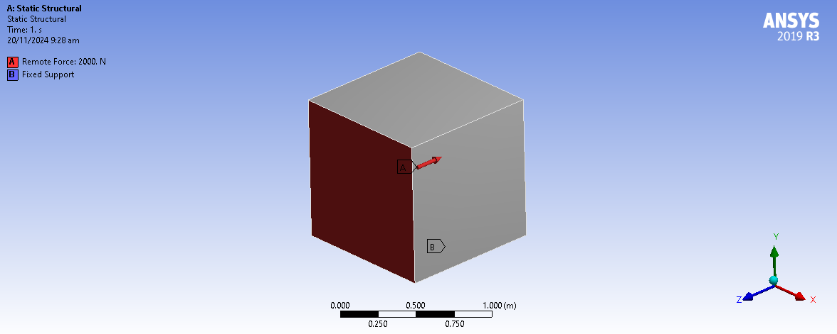
* Equivalent Von-Mises stress and convergence under that stress.

